

Oxidation and Reduction
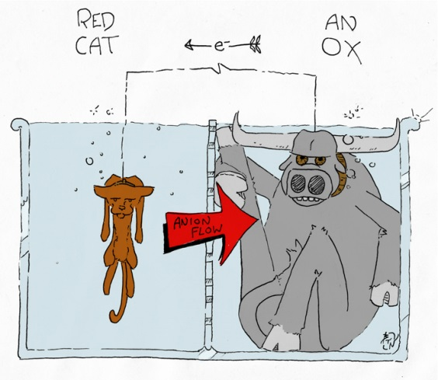

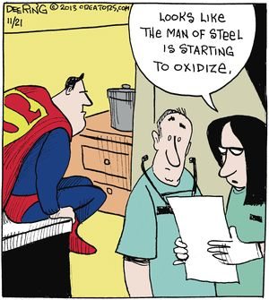


(Norwood n.d.)

(Varricchio n.d.)

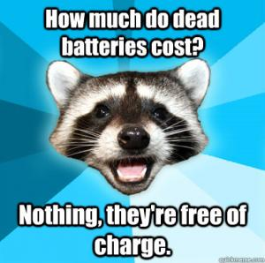

(ServoCity 2015)


(Kappit n.d.)

(Chemistry Cat n.d.)
Week | topic | unit content | assessment
11 – 14 | Oxidation and Reduction | - the species being oxidised and reduced in a redox reaction can be identified using oxidation numbers  - oxidation-reduction (redox) reactions involve the transfer of one or more electrons from one species to another  - oxidation involves the loss of electrons from a chemical species, and reduction involves the gain of electrons by a chemical species; these processes can be represented using half-equations and redox equations (acidic conditions only)  - a range of reactions involve the oxidation of one species and reduction of another species, including metal and halogen displacement reactions, and combustion in both limited and excess oxygen environments  - the relative strength of oxidising and reducing agents can be determined by comparing standard electrode potentials, and can be used to predict reaction tendency  - electrochemical cells, including galvanic and electrolytic cells, consist of oxidation and reduction half-reactions connected via an external circuit through which electrons move from the anode (oxidation reaction) to the cathode (reduction reaction)  - galvanic cells produce an electric current from a spontaneous redox reaction  - the electric potential difference of a cell under standard conditions can be calculated from standard electrode potentials; these values can be used to compare the voltages generated by cells constructed from different materials  - electrochemical cells can be described in terms of the reactions occurring at the anode and cathode, the role of the electrolyte, salt bridge (galvanic cell), ion migration, and electron flow in the external circuit  - corrosion of iron is an electrochemical process that can be prevented by a range of techniques, including by exclusion of oxygen and/or water and through cathodic protection and sacrificial anodes  - cell diagrams can be used to represent electrochemical cells  - electrolytic cells use an external electrical potential difference to provide the energy to allow a non-spontaneous redox reaction to occur  - describe the use of electrolysis in electrolytic refining, including for purification of copper, and metal electroplating, including for silver  - spontaneous redox reactions can be used as a source of electrical energy, including primary cells (for example, the Leclanché cell), secondary cells (for example, the lead-acid accumulator) and fuel cells (for example, the hydrogen fuel cell). Fuel cells are a potential lower-emission alternative to the internal combustion engine and are already being used to power various modes of transport. Organisations, including the International Partnership for Hydrogen and Fuel Cells in the Economy, have been created to foster global cooperation on research and development, common codes and standards, and information sharing on infrastructure development. | Extended Response 1  Practical 3  Test 3

Redox Reactions
Reduction and oxidation (redox) reactions involve electron transfer. A species is oxidised when it loses one or more electrons and reduced when it gains one or more electrons (______________ _____________________________________________).
To help determine which atom or ion is oxidised and which is reduced, the concept of oxidation numbers has been developed. An atom’s oxidation number can be described as ‘the charge the atom would have if the bonds were purely ionic’. The following rules are used to help determine oxidation numbers.
- Atoms in their elemental state have an oxidation number of zero
e.g. _________________________________________
- Monatomic ions have an oxidation number equal to their charge
e.g. _________________________________________
- Hydrogen has an oxidation number of +1 except in metal hydrides where it has an oxidation number of -1
e.g. _________________________________________
- Oxygen has an oxidation number of -2 except in the case of F₂O where it has an oxidation number of +2 and in peroxides where it has an oxidation number of -1
e.g. _________________________________________
- Group I and II elements have oxidation numbers of +1 and +2 respectively.
- The sum total of the oxidation numbers is equal to the charge on the compound or ion.

Examples: Determine the oxidation number of each of the atoms in the following species.
HCl SO₄²⁻ P₂O₅ HClO₂ HNO₃ H₂O₂ BaH₂ KMnO₄ Cr₂O₇²⁻

If an atom is oxidised, its oxidation number increases by the number of electrons it lost
e.g. Mg → Mg²⁺
oxidation number (0) (+2) i.e. lost two electrons

If an atom is reduced, its oxidation number decreases by the number of electrons it gained
e.g. N → N³⁻
oxidation number (0) (-3) i.e. gained three electrons

In a redox reaction, the species that is oxidised is called the ______________________________ and the species that is reduced is called the __________________________________________.

Whether a reaction is redox or not can be determined using oxidation numbers. ______________ ______________________________________________________________________________

Examples: Determine whether each of the following reactions are redox or not. If it is a redox reaction, determine which species is oxidised and which species is reduced as well as which species is the oxidant and which is the reductant.

Zn_{(s)} + 2HCl_{(aq)} → ZnCl_{2(aq)} + H_{2(g)}

2CrO₄²⁻_{(aq)} + 2H⁺_{(aq)} → Cr₂O₇²⁻_{(aq)} + H₂O_{(l)}

2CrO₂⁻_{(aq)} + 3H₂O_{2(l)} + OH‒_{(aq)} → 2CrO₄²⁻_{(aq)} + 4H₂O_{(l)}

A disproportionation reaction involves one species that is both oxidised and reduced.

e.g.

A number of common reactions are also redox reactions. These include:

Metal-metal ion displacement
Electron transfer takes place from a metal element to the metal ion of a less reactive metal. Relative reactivity can be determined by using the table of standard reduction potentials in the data booklet.
______________________________________________________________________________
e.g.
Example: Determine if the following metals will undergo displacement.
Ag_{(s)} + Mn²⁺_{(aq)}, Sn_{(s)} + Cu²⁺_{(aq)}, Fe_{(s)} + Ca²⁺_{(aq)}, Ni _{(s)} + Au³⁺ _{(aq)}
Metal-hydrogen ion displacement
Electron transfer takes place from a metal element to the hydrogen ion. Relative reactivity can be determined by using the table of standard reduction potentials in the data booklet.
____________________________________________________________________________________________________________________________________________________________
e.g.
Example: Determine if the following metals will undergo displacement with H⁺.
Zn_{(s)}, Ag_{(s)}, Cd_{(s)}, Cu_{(s)}

Halogen-halide ion displacement

Electron transfer takes place from a halide ion to a less reactive halogen. Relative reactivity can be determined by using the table of standard reduction potentials in the data booklet.
______________________________________________________________________________
e.g.

Example: Determine if the following halogens will undergo displacement.
Br_{2(l)} + F‒_{(aq)}, F_{2(g)} + I‒_{(aq)}, I_{2(s)} + Br‒_{(aq)}, Cl_{2(s)} + I‒ _{(aq)}

Combustion
Electron transfer takes place from oxygen to carbon.

(excess oxygen) e.g.
(limited oxygen) e.g.

Corrosion
Corrosion is the oxidation of a metal in the presence of air. Electron transfer takes place from the metal to oxygen.
e.g.

Rusting is a specific form of corrosion involving iron. It is quite a complex reaction but at its simplest, it can be considered as the transfer of electrons from iron to oxygen in the presence of water through the following reaction:

Complete Lucarelli Set 8 Oxidation Numbers and Redox Reactions (p66)

Half-Equations
Redox reactions involve both oxidation and reduction. It is possible to write the oxidation and reduction reactions separate in the form of half-equations. There are a number of rules that guide how to write correct half-equations.

- Balance all atoms.
- Balance oxygen by adding water to the side that is deficient in oxygen.
- Balance hydrogen by adding hydrogen ions to the side that is deficient in hydrogen.
- Balance charges by adding electrons to one side.
- Write in states.

E.g. Write the half-equations for the following reactions:
- Sn_{(s)} → Sn⁴⁺_{(aq)}
- F_{2(g)} → F‒_{(aq)}
- Cr₂O₇²⁻_{(aq)} → Cr³⁺_{(aq)}
- NO₃‒_{(aq)} → NO_{2(g)}
Overall Redox Equations
When writing balanced, overall redox reactions, the steps to follow include:

- Determine which species is being oxidised and which is being reduced.
- For each half-equation, balance atoms (adding water and hydrogen ions if needed) and charges (by adding electrons).
- Multiply one or both half equations so that the number of electrons in each are equal.
- Add the two half-equations together cancelling out any common species.
- Write in states.

E.g. Write balanced, overall redox reactions for the following
- Mg_{(s)} + H⁺_{(aq)} → Mg²⁺_{(aq)} + H_{2(g)}

- Fe³⁺_{(aq)} + H₂O_{2(l)} → Fe²⁺_{(aq)} + O_{2(g)}

- MnO₄‒_{(aq)} + H₂C₂O_{4(aq)} → Mn²⁺_{(aq)} + CO_{2(g)}

- C₂H₅OH_{(l)} + Cr₂O₇²⁻_{(aq)} + H⁺_{(aq)} → CH₃CHO_{(l)} + Cr³⁺_{(aq)} + H₂O_{(l)}

Complete Lucarelli Set 9 Balancing Half-Equations and Redox Reactions (p68)

Electrochemistry

Electrochemical cells allow energy to transform between the forms of chemical potential energy and electrical energy. Galvanic cells use a redox reaction to produce a voltage (potential difference) that results in an electric current. It does this by preventing direct contact between the oxidant and reductant.
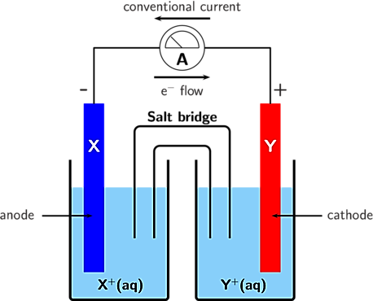
cations
anions
(reduction)
(oxidation)

(Siyavula n.d.)

Components and terminology of electrochemical cells
- _____________ – electrical conductors on which electron transfer occurs at the surface.
- _____________ – electrode where oxidation occurs (an ox). It is denoted negative (‒).
- _____________ – electrode where reduction occurs (red cat). It is denoted positive (+).
- _____________ – solution which contains ions that conduct charge.
- _____________ – contains a non-reactive electrolyte solution. It prevents direct contact of the oxidant and reductant and prevents charge building up in each half-cell. Anions flow from the salt bridge towards the anode and cations flow towards the cation.
- ________________________ – half-cell where oxidation occurs. It contains the anode in an electrolyte.
- ________________________ – half-cell where reduction occurs. It contains the cathode in an electrolyte.
- __________________ – a conductive path (usually wire) which allows electron flow to occur between cells.

The Daniell cell is a classic example of an electrochemical cell.
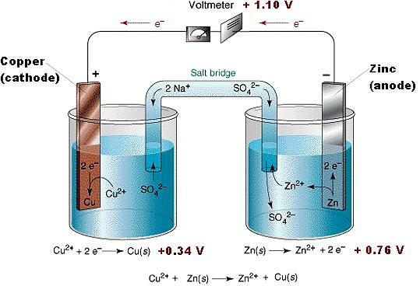

(Crujera and Perkin 2014)

Write the two half-equations and the overall redox equation for this electrochemical cell.

Reduction:
Oxidation:
Overall:

The table of standards reduction potentials is used to rank the strength of oxidising agents and can be used to calculate the voltage produced in an electrochemical cell. Reduction potentials are determined by measuring them against a reference cell which is the H⁺_{(aq)}│H_{2(g)} half-cell (which is arbitrarily given a standard reduction potential (E°) of 0.00 V). When operating at standard conditions (i.e. 25 °C, 1.0 mol L⁻¹ and 100.0 kPa) the cell produces a voltage known as the standard cell potential (E°_{cell}).

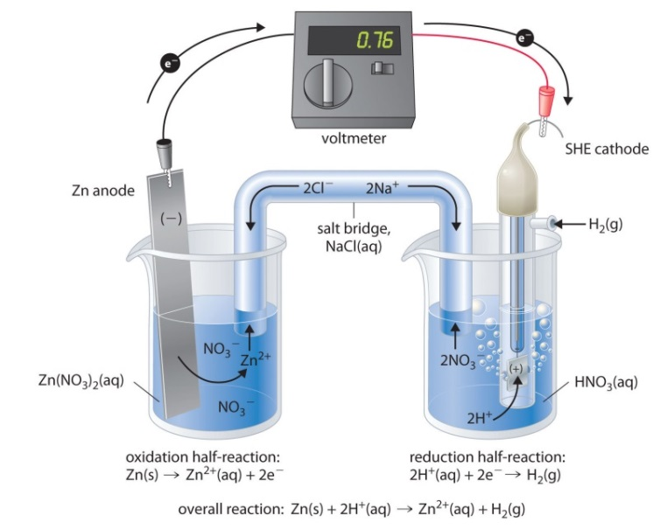

(Schmitz 2012)
The standard reduction potentials table is a list of half-cells ranked in order of increasing ability to lose electrons. This means that the most powerful oxidising agents are on the top left of the table and the most powerful reducing agents are on the bottom right of the table. As such, the species which displays the more positive Eº value will be reduced (the oxidant).

Example: Predict which cell is the anode compartment in each of the following:

    - Zn_{(s)} |Zn²⁺_{(aq)} || Ag⁺_{(aq)} | Ag_{(s)}
    - Fe_{(s)} |Fe⁺²_{(aq)} || Mg²⁺_{(aq)} | Mg_{(s)}
    - Fe_{(s)} |Fe²⁺_{(aq)} || Cu²⁺_{(aq)} | Cu_{(s)}

Example Use the electrochemical series to decide the following:
- Is chlorine a powerful oxidiser or a poor oxidiser?
- Is the sodium ion a powerful or poor oxidant?
- Which is the more powerful oxidiser – iodine or chlorine?
- Which is the more powerful oxidising agent – iron (III) or hydrogen ions?
- Which is the more powerful reductant – magnesium or gold?
- Which is the more powerful reducer – chloride ions or iodide?

The E°_{cell} or voltage or E.M.F. of an electrochemical cell is a measure of the difference in the standard potentials of each half-cell. A positive E°_{cell} indicates that a reaction will occur spontaneously. A negative E°_{cell} indicates that a reaction will not occur without external assistance.
When determining E°_{cell} it is important to remember that the values given in the standard reduction potentials table are for reduction half-equations. Once the oxidation half-equation has been identified, the sign of its E° value must be reversed. This means the E°_{cell} can be calculated using the formula:

Electrochemical cells can be represented in the following notation: Zn_{(s)}|Zn²⁺_{(aq)} || Ag⁺_{(aq)} |Ag_{(s)}
or, if inert electrodes are used Pt_{(s)} |ClO₃–_{(aq)}, ClO₄–_{(aq)} || MnO₄–_{(aq)}, Mn²⁺_{(aq)} |Pt_{(s)}
where | = phase boundary, || = salt bridge.

Redox reactions are not limited to those between metals and metal ions. As such, some half-cells require inert electrodes (most often graphite or platinum).
The type of electrode that can be used for particular half-cells include:
- Reactions involving metals and metal ions – ___________ is the electrode (eg Mg and Mg²⁺).
- Reactions involving metals ions in different oxidation states – _____________ electrode is used (eg Cr³⁺ and Cr⁶⁺).
- Reactions involving a dissolved non-metal and its ions – _____________ electrode is used (eg Br₂ and Br–).
- Reactions involving a gaseous non-metal and its ions – _____________ electrode is used (eg Cl₂ and Cl–).

Example: Find the overall reaction and the E°_{cell} for the cell: Zn_{(s)} | Zn²⁺_{(aq)} || Ag⁺_{(aq)} | Ag_{(s)}
Step One: Write the half-cell equations and their E° from the standard reduction potentials table.

Step Two: Determine the reduction half-equation which has the more positive Eº.

Step Three: The E°_{cell} of the can be calculated by performing E°_{reduction} + E°_{oxidation} (remember you must reverse the sign on the oxidation half-equation).

Step Four: Reverse the direction of the oxidation half-equation and rewrite the full redox equation (remember to balance the electrons).

(NB: Although Eº values are additive, we do not multiply them if the half-equation needs to be multiplied in order to write the overall redox equation).

Example: For the galvanic cell shown below determine the following:
- The oxidising agent and reducing agent
- The anode and cathode
- The overall redox reaction
- The E_{cell}º
- The direction of flow of electrons, anions and cations
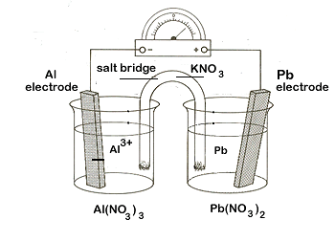
- A suitable salt bridge
- The changes you would expect to observe at the anode and cathode

(Lawson n.d.)

Complete Lucarelli Set 10 Understanding Galvanic Cells (p75)
The Corrosion of Iron

Corrosion of iron requires both oxygen and water.

Oxidation (anode):
Reduction (cathode):
Precipitation:
Further oxidation of the iron (II) hydroxide then occurs.
This may then partially dehydrate to form rust, Fe₂O₃.xH₂O.

Overall, the equation is given by:

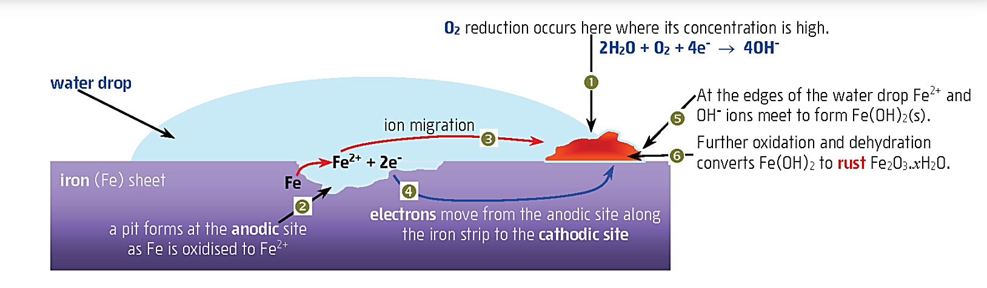

(Lucarelli 2020)
The water acts an electrolyte and salt bridge. Oxygen reduction occurs at the point where oxygen is at its greatest concentration and iron oxidation occurs where oxygen concentration is lowest (i.e. in two separate sites). The Fe²⁺ ions then migrate to the cathode to react with OH– ions. The process of rusting can be affected by the following factors:

- _____________: this is the oxidising agent. The greater the concentration of oxygen, the greater the rate of corrosion.
- _____________: increases the flow of ions between anodic and cathodic sites which increases the rate of corrosion.
- _____________: the lower the pH, the greater the rate of corrosion as the reduction potential of water increases (i.e. its reduction becomes more favourable).
- _____________: improves the efficiency of water as the salt bridge and increases the rate of corrosion.
- __________________________________________: if iron is in contact with a less reactive metal (i.e. more positive reduction potential), the rate of corrosion increases (more sites now available for iron to oxidise). If iron is in contact with a more reactive metal (i.e. less positive reduction potential), the rate of corrosion decreases.
- _____________: increased temperature increases the rate of corrosion.

Prevention of Rusting
A number of methods can be used to prevent or minimise the rusting process.

- ________________________: prevents contact with oxygen and water eg painting, plastic, oil, etc.
- ________________________: prevents contact with oxygen and water eg Cu, Sn, Pb, etc. This can be problematic if the metallic barrier is damaged as it makes the point of contact with iron more anodic and so the iron will corrode faster.
- _______________________: coating with the more reactive metal, zinc. Zinc oxidises more readily and forms a protective layer over the iron (ZnCO₃.Zn(OH)₂).
- ______________________________________________: a more reactive metal is placed in contact with the iron. The more reactive metal oxidises and must be replaced periodically. The iron now becomes the site for reduction and so O₂ is reduced at this site. A very damp or wet environment is needed to act as a salt bridge.
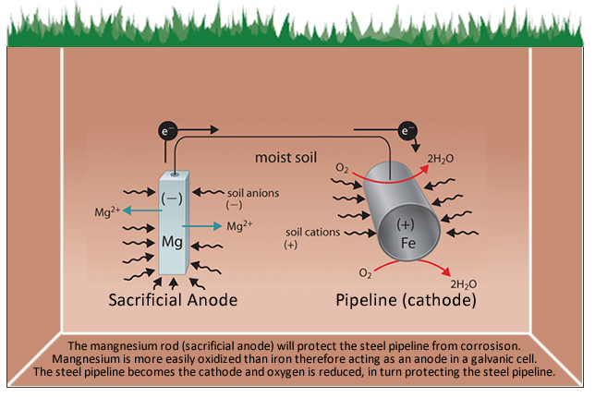

(OTDS UK Ltd 2021)

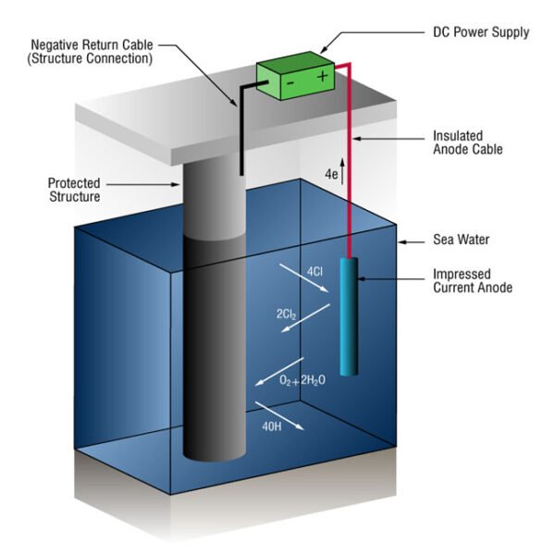
- ______________________________________: the iron is connected to the negative terminal of a low voltage DC current. The excess of electrons prevents oxidation. The positive terminal of the power supply is attached to a piece of scrap metal or an inert material (eg Pt (which causes oxidation of H₂O) that is oxidised over time. As is the case in the use of a sacrificial anode, a very damp or wet environment is needed to act as a salt bridge.

(Marinethai.net 2016)

Complete Lucarelli Set 12 Electrochemistry in Action Questions 19 – 22 (p96)

Electrolytic Cells

Electrolysis occurs in an electrolytic cell and is essentially the reverse process to that which occurs in a galvanic cell (i.e. an electric current is applied to the cell in order to make a redox reaction occur).

Components and terminology of electrolytic cells
- ____________ – electrode where oxidation occurs. It is attached to the positive terminal of the power supply and is denoted positive (+).
- ____________ – electrode where reduction occurs. It is denoted positive (‒).
- ____________________ – supplies the electrical energy which causes the redox reaction to occur. It pushes electrons to the cathode and draws them from the anode.
- ____________ – molten salt or aqueous solution in which the electrodes are immersed. Anions are attracted to the anode, cations to the cathode.
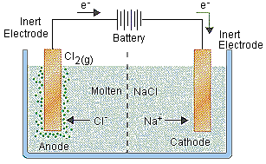
+
‒

(Bodner Group n.d.)

Electrolysis of a Molten Salt

Inert electrodes are placed in a molten salt and a voltage is applied. The voltage causes one electrode (cathode) to become negatively charged and the cations are attracted to this electrode where they are reduced. Simultaneously, the voltage causes the other electrode (anode) to become positively charged and the anions are attracted to this electrode where they are oxidised. In a molten salt, the ions are converted to their elemental forms.

Example: An electrolytic cell contains two inert electrodes placed in molten lead (II) bromide.
- Draw a labelled diagram showing this cell.
- Draw the electron flow on your diagram.
- Label the anode and cathode. Write the half-equations that occur at each electrode.
- Show the direction of ion migration.
- Write the overall, balanced redox reaction.
- Describe any observations you would note at each electrode.
- Calculate the minimum voltage needing to be applied to cause the redox reaction to occur.

Electrolysis of an Aqueous Solution

Electrodes (which may be inert or otherwise) are placed in an aqueous solution containing a dissolved salt and a voltage is applied. The voltage causes one electrode (cathode) to become negatively charged and the cations are attracted to this electrode where they are reduced. Simultaneously, the voltage causes the other electrode (anode) to become positively charged and the anions are attracted to this electrode where they are oxidised. Depending on what is present in the cell, the aqueous salt, electrode(s) or water may be oxidised or reduced.

If water is reduced, the half-equation to use is:

If water is oxidised, the half-equation to use is:

When determining which species is undergoing reduction and which is undergoing oxidation, it is necessary to write all possible reduction and oxidation half-equations that could take place and then _________________________________________________________________________ ___________________________________.

Example: An electrolytic cell contains inert electrodes placed in an aqueous solution of manganese (II) iodide.
- Draw a labelled diagram showing this cell.
- Draw the electron flow on your diagram.
- Label the anode and cathode. Write the half-equations that occur at each electrode.
- Show the direction of ion migration.
- Write the overall, balanced redox reaction.
- Describe any observations you would note at each electrode.
- If tin electrodes were used instead of inert electrodes would this have made a difference? If so, write the new balanced, redox equation and observations.

Complete Lucarelli Set 11 Electrolysis (p80)
Applications of Electrochemical Cells

- Electrolysis of Molten NaCl – The Downs Cell.
____________________________________________________________________________________________________________________________________________________________
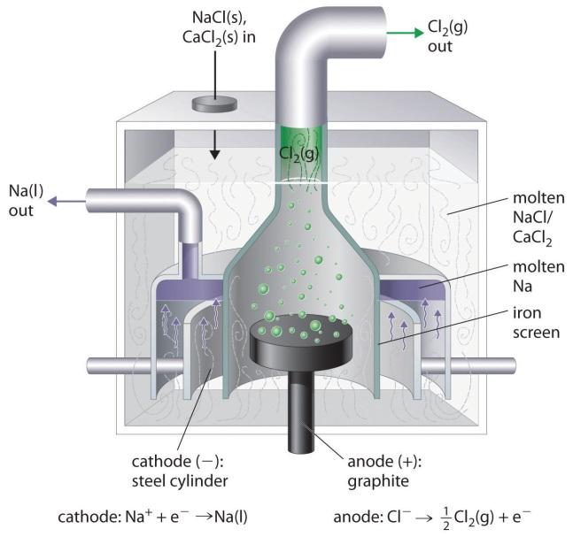

(Larsen n.d.)

The melting point of NaCl (approximately 800ºC) is reduced (to approximately 600ºC) by adding CaCI₂ to the mixture. The anode is graphite and the cathode is iron. The half reactions occurring are:

anode:
cathode:

The chlorine is piped off as a gas and the molten sodium (which rises to the top of the molten salt due to a lesser density) is tapped off in the absence of air. The chlorine gas and molten sodium must not be allowed to come into contact as they are reactive enough to reform the molten NaCl.
This process of commercially producing metals from their molten salts is referred to as electrowinning. Calculate the minimum voltage required in this cell.

- Electroplating
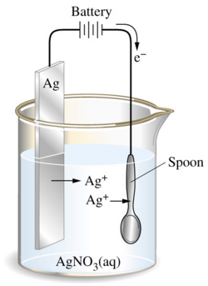
Electroplating involves ____________________________________________________________ ______________________________________________________________________________ In this case, the metal to be used as the coating is the anode and the cathode is the object to be coated.
Example: Silver plating a spoon.

(Larsen n.d.)
anode:
cathode:

- Electrorefining
Electrorefining involves ___________________________________________________________ ______________________________________________________________________________

In the example of electrorefining copper, the anode is made up of the impure (blister) copper metal (impurities often include Zn, Fe, Ni, Au, Ag and Pt) and the cathode is made of pure copper. The electrolyte in this case is a copper (II) sulphate solution.

(Lewis and Lewis 2012)

The impure copper is oxidised at the anode (along with Zn, Fe, and Ni) whilst the other metals fall to the bottom as an anode slime. As the voltage is carefully controlled, only the copper (II) ions are then reduced and deposited at the cathode.
anode:

cathode:

- Primary Cells

These are _____________________________________________________________________

The dry or Leclanché cell is the most common type of primary cell. It produces a voltage of
1.48 V. It consists of a zinc anode (the casing) and a graphite rod cathode surrounded by powdered manganese dioxide (MnO₂). The electrolyte is a moist paste of ammonium chloride and zinc chloride. The half reactions are complex but may be represented as:

anode:

cathode:

overall:

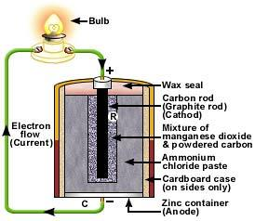

(tymkrs 2011)

This battery cannot be recharged because the zinc ions are removed from the anode and eventually the ammonium chloride produces an acidic environment that corrodes the zinc casing.

- Secondary Cells
These are _____________________________________________________________________

The lead-acid accumulator battery is a secondary cell. It is made up of six cells connected in series, producing a voltage of around 12 V. It produces a much larger current than a dry cell. The cathode is a grid of lead alloy packed with lead (IV) oxide powder. The anode is a grid of lead alloy packed with spongy lead and the electrolyte is a solution of 35 % v/v sulfuric acid.

anode:
cathode:
overall:

The lead sulphate produced coats the electrodes. To charge the battery the car’s alternator provides an electric current which causes the reverse reaction to take place.

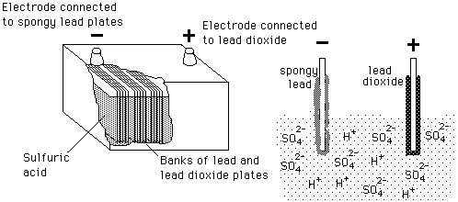

(Nave n.d.)
- Fuel Cells

These cells ____________________________________________________________________ ___________________________________________________________________________________________________________________________________________________________.

In the alkaline hydrogen fuel cell, gaseous hydrogen and oxygen are continuously fed into the cell producing only water as the waste product.

anode:
cathode:
overall:
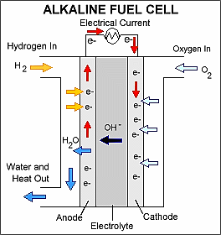

(Konrad 2013)

Complete Lucarelli Set 12: Electrochemistry in Action (p90)

Bibliography
askllTians.com. 2006. "Electrolysis and Electrochemical Cells." askllTians. Accessed March 16, 2016. http://www.askiitians.com/iit-jee-chemistry/physical-chemistry/electrolysis-and-electrolytic-cell.aspx.
Bodner Group. n.d. "Electrolytic Cells." Bodner Research Group. Accessed March 16, 2016. http://chemed.chem.purdue.edu/genchem/topicreview/bp/ch20/faraday.php.
Chemistry Cat. n.d. "The Science Nerd in Me <3." Pinterest. Accessed March 17, 2016. https://www.pinterest.com/missamberlee21/the-science-nerd-in-me-3/.
Crujera, A, and B Perkin. 2014. "The Basis of Electro-Etching: A Simplified Explanation." Nontoxicprint. Accessed March 13, 2016. http://www.nontoxicprint.com/electroetchbasics.htm.
Kappit. n.d. "Battery Puns." Kappit. Accessed March 17, 2016. http://www.kappit.com/tag/battery-puns/.
Konrad, T. 2013. "12 Hydrogen and Fuel Cell Stocks." Forbes Investing. December 13. Accessed March 16, 2016. http://www.forbes.com/sites/tomkonrad/2013/12/11/twelve-hydrogen-and-fuel-cell-stocks/#6c3ff87d326d.
Larsen, Delmar. n.d. "Electrolysis." UCDavis ChemWiki. Accessed March 16, 2016. http://chemwiki.ucdavis.edu/Core/Analytical_Chemistry/Electrochemistry/Electrolytic_Cells/Electrolysis_I.
Lawson, Peggy. n.d. "Redox Reactions and Electrochemistry." Chemistry 30. Accessed March 17, 2016. https://www.spiritsd.ca/curr_content/chem30_05/6_redox/redox2_4.htm.
Lewis, C, and P Lewis. 2012. Chemistry for WA 2. Port Melbourne: Pearson Australia.
Lucarelli, Nick. 2020. Essential Chemistry ATAR Chemistry Units 3 + 4. Welshpool: Lucas Publications.
Marinethai.net. 2016. Cathodic Protection. Accessed April 19, 2021. https://www.marinethai.net/en/product/cathodic-protection/.
Nave, R. n.d. "Lead-Acid Battery." HyperPhysics. Accessed March 16, 2016. http://hyperphysics.phy-astr.gsu.edu/hbase/electric/leadacid.html.
Norwood, B. n.d. "3 Mnemonic Devices for Redox Reactions." Learning Laboratory. Accessed March 12, 2016. http://learning-laboratory.com/redox-reactions-oxidation-reduction/.
OTDS UK Ltd. 2021. Sacrificial Anode Cathodic Protection (SACP). Accessed April 19, 2021. http://www.otds.co.uk/admin/productFiles/40/Sacrificial%20Anode%20Pipeline.jpg.
Schmitz, Andy. 2012. "Electrochemistry." Creative Commons. Accessed March 13, 2016. http://2012books.lardbucket.org/books/principles-of-general-chemistry-v1.0/s23-electrochemistry.html.
ServoCity. 2015. "Powering Your Project - Happy National Battery Day." ServoCity Blog. February 17. Accessed March 16, 2016. https://www.servocity.com/blog/?p=609.
Siyavula. n.d. "Electrochemical Reactions." Everything Maths and Science. Accessed March 12, 2016. http://www.everythingmaths.co.za/science/grade-12/13-electrochemical-reactions/13-electrochemical-reactions-03.cnxmlplus.
tymkrs. 2011. "Toymaker Television." Zinc-Carbon Battery Research I. July 15. Accessed March 16, 2016. http://tymkrs.tumblr.com/post/7654140694/zinc-carbon-battery-research-i.
Varricchio, A. n.d. "Super Oxidation." Pinterest. Accessed March 16, 2016. https://www.pinterest.com/pin/75857574947809615/.

